SET-10 — Survey Responses Analysis
AIM
To analyze survey response data and visualize the distribution of responses using grouped bar chart, stacked bar chart, and table.
ALGORITHM
- Start RStudio.
- Create the Survey Responses dataset.
- Create a grouped bar chart for Question 1.
- Create a stacked bar chart for all three questions.
- Display the survey response data in a table.
- Add suitable titles and labels.
- Display the output.
- Stop.
R CODE
survey<-
data.frame
(Survey_ID=c(1,2,3),Question_1=c("A","B","C"),Question_2=c("B","A","A"),
Question_3=c("C","D","B"))
q1<-table(survey$Question_1)
barplot(q1,main="Distribution of Question 1 Responses",xlab="Answer",ylab="Frequency")
responses<-rbind(table
(survey$Question_1)
,table
(survey$Question_2),
Table
(survey$Question_3))
responses[is.na(responses)]<-0
barplot(responses,beside=FALSE,main="Overall Distribution of Responses",xlab="Questions",ylab="Frequency",names.arg=c
("Question 1","Question 2","Question 3"))
survey

OUTPUT
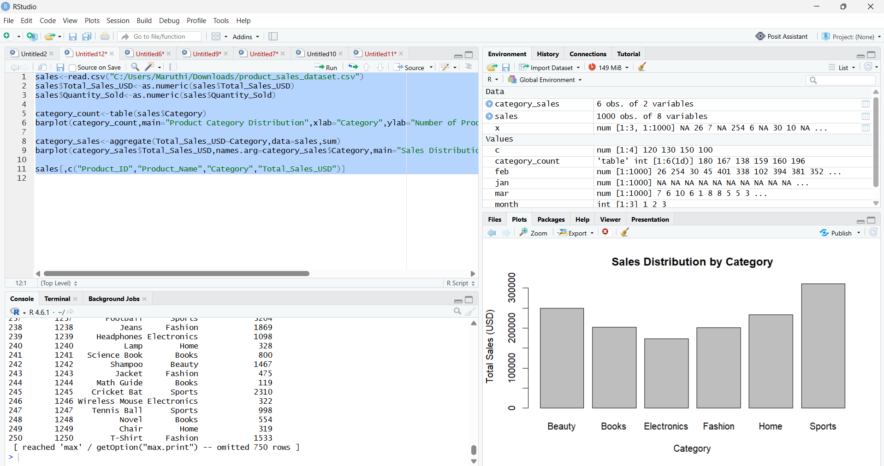RESULT
Thus, the Survey Response data was successfully analyzed using R programming. The grouped bar chart, stacked bar chart, and survey response table were successfully created.

